RABAUL and MONTEVIDEO MARU GROUP,
75th ANNIVERSARY COMMEMORATIVE SERVICE AND DINNER
AUSTRALIAN WAR MEMORIAL, CANBERRA

Saturday 1 July 2017
PAPUA NEW GUINEA ASSOCIATION OF AUSTRALIA Inc
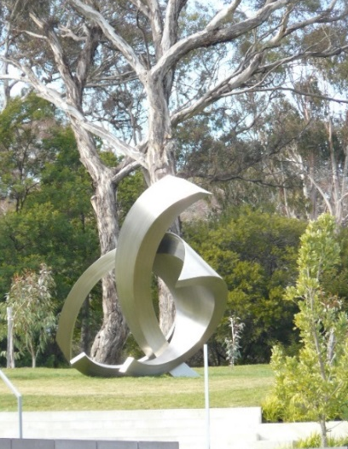
75th Anniversary Service
Saturday 1 July 2017
Time: 1 pm
Venue: Australian War Memorial, Canberra, ACT.
All welcome – please let your family and friends know.

RSVP by 8 June 2017: http://pngaa.org/site/blog/2017/03/01/rabaul-and-montevideo-maru-75th-anniversary-commemorative-service-1-july-2017-australian-war-memorial-canberra-act/

75th Anniversary Commemorative Dinner
Saturday 1 July 2017
Time: 6.00pm
Venue: Mercure Canberra, Corner of Ainslie and Limestone Ave, Braddon, ACT 2612
COST: $80 - 3 course meal including soup - Payment will confirm booking.
RSVP: 8 June 2017
Further information and payments:
http://pngaa.org/site/blog/2017/03/01/1-july-2017-rabaul-and-montevideo-maru-75th-anniversary-commemorative-dinner-canberra-mercure-hotel/

Please email to admin@memorial.org.au advising the following details.

§ The full name of each person who wishes to attend.
§ The age of each person who wishes to attend (optional but helpful).
§ Any mobility issue
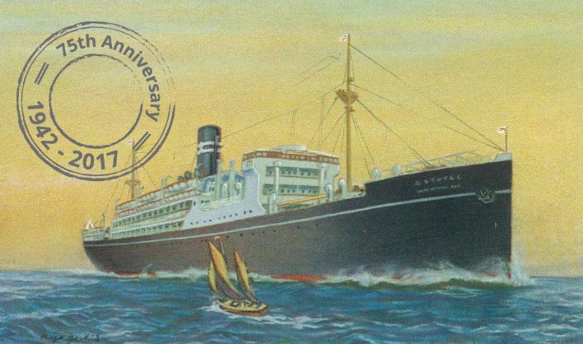
§ The full postal address, phone number (home and mobile) and email of each person who wishes to attend.
§ The relationship, if any, of the person to the events of 1942 (if you did not attend a previous event in Canberra).
§ The address and phone number, where each person intends to stay while in Canberra.
§ Any other people you are travelling with.

Even if you do not have all this information at this stage, please tell us what you can.
www.pngaa/org www.memorial.org.au
Facebook: Rabaul and Montevideo Maru Society
Facebook: Papua New Guinea Association of Australia

